**PART-A**

**Title of Micro Project:** Artificial Fishpond Water Level Control System.

1. **Brief Introduction:** A PLC (programmable logic controller) is an industrial digital computer which has been ruggedized and adapted for the control of manufacturing process, such as assembly lines, or robotic devices, or any activity that requires high reliability control and ease of programming and process fault diagnosis. Here we can control the artificial fishpond water level.

**2.0 Aim of the Micro Project:** To develop and test a ladder diagram for Artificial Fishpond Water Level Control System.

**3.0 Action Plan:**

|  |  |  |  |  |
| --- | --- | --- | --- | --- |
| **Sr.**  **No.** | **Details of Activity** | **Planned Start Date** | **Planned Finish Date** | **Name of Responsible Team Members** |
| 1 | Study of the topic | 07/09/2019 | 11/09/2019 | Satyajeet |
| 2 | Practical Performance | 15/09/2019 | 20/09/2019 | Aman |
| 3 | Theoretical verification | 22/09/2019 | 25/09/2019 | All member |
| 4 | Preparation of report | 26/09/2019 | 30/09/2019 | All member |
| 5 | Submission of project |  |  |  |

**4.0 Resources Required (Such as raw material, some machining facility, software etc.**

|  |  |  |  |  |
| --- | --- | --- | --- | --- |
| **Sr.** | **Name of Resource/Material** | **Specifications** | **Qty** | **Remarks** |
| **No.** |  |  |  |  |
| 1 | Computer | Intel Process core 13 or 17 | 1 |  |
| 2 | Software | WPL software | 1 |  |

**PART-B**

**Title of Micro Project:** Artificial Fishpond Water Level Control System.

**1.0 Brief Description:** A programmable logic controller (PLC) or programmable controller is an industrial digital computer which has been ruggedized and adapted for the control of manufacturing processes, such as assembly lines, or robotic devices, or any activity that requires high reliability control and ease of programming and process fault diagnosis. In this project, Delta PLC is used for controlling the inputs and outputs. Input supply toThe PLC is given through a SMPS. The rating of the SMPS is 24V DC. The PLC used here is aCompact PLC which has fixed number of inputs and outputs. In this kind of PLC model, the CPUContain 8 digital inputs and 8 digital outputs. Water level sensor has been used to sense the water level. Toggle switches are used to serve the purpose of some inputs to the PLC.

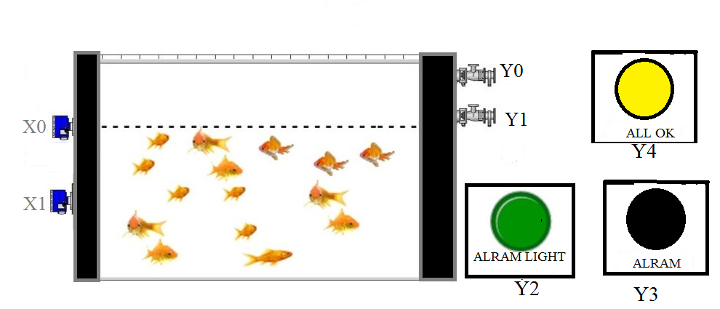

**2.0 Aim of Micro Project:** To develop and test a ladder diagram for Artificial Fishpond Water Level Control System.

**3.0 Course Outcomes Integrated**

CO4: Maintain PLC based process control systems.

**CO5:** Maintain various components of PLC based process control systems.

**4.0 Resources Required**

|  |  |  |  |  |
| --- | --- | --- | --- | --- |
| **Sr.** | **Name of Resource/Material** | **Specifications** | **Qty** | **Remarks** |
| **No.** |  |  |  |  |
| 1 | Computer | Intel Process core 13 or 17 | 1 |  |
| 2 | Software | WPL software | 1 |  |

**5.0 Outputs of the Micro Projects:**

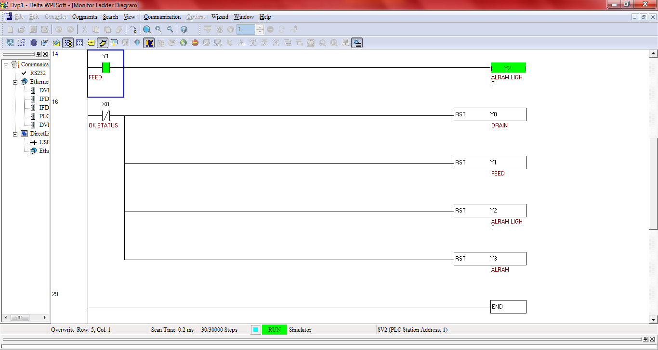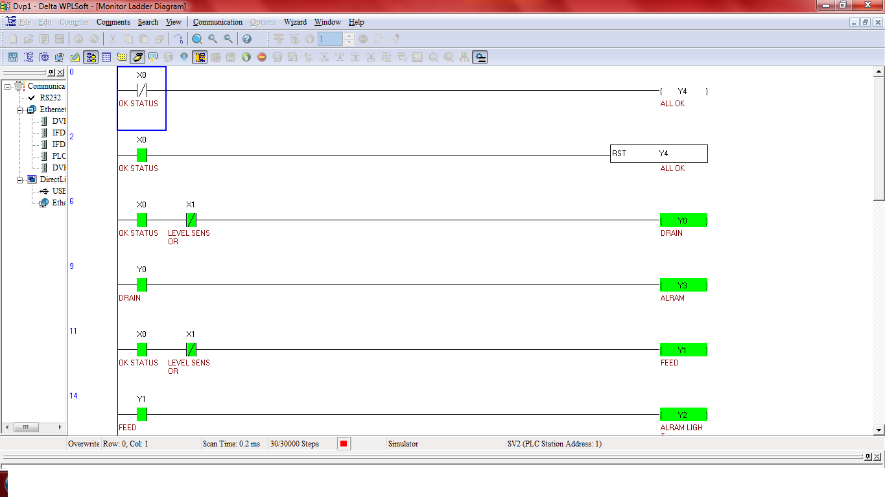

**Number of PLC Inputs Required**

If X0=0= All ok.

If X0=1= Not ok.

If X1=0= Water level low.

If X1=1= Water level high.

**Number of PLC Outputs Required**

If Y0= Water drain.

If Y1= Water feed.

If Y2= Alarm light.

If Y3= Alarm (buzzer).

If Y4= All ok.

**PLC Ladder Program Description:**

In the above program, 0 is normally closed, X0 and X1 is the level sensor, Y0 is the drain pump, Y1 is the feed pump, Y2 is the Alarm light, Y3 is the Alarm, and Y4 is the all ok.

 Here we considered one artificial fishpond, two level sensors and two pumps for system monitor & control. Here we write a program that will control whole system. System will maintain normal level and it does not allow water level to go up or down to maintain the normal level. If water level goes down from the normal level then system will feed water in the fishpond and if water level goes up from the normal level then system will drain water from the fishpond. In this ladder diagram, X0 is 0 the water level is OK. When X1 become 0 the water level is low and X0 become 1 then the feeding pump is start (Y1) and Y3 is ON (Alarm light). When X1 become 1 the water level is high then Drain pump is start (Y0) and Y3 is ON (Alarm).

**Annexure-IIA**

**Name of Student:** Aman Shaikh **Enrolment No:** 1710900104

**Name of Programme: Electronic and telecommunication Semester: 5**

**Course Title: Control System and PLC Code: 22531**

**Title of the Micro Project:** Artificial Fishpond Water Level Control System**.**

**Course Outcomes Achieved**: Maintain PLC based process control system.

# Micro Project Evaluation Sheet

|  |  |  |  |  |
| --- | --- | --- | --- | --- |
| **Process Assessment** | | **Product Assessment** | | **Total Marks 10** |
| **Part-A**  **Project Proposal**  **(Mark-2)** | **Project**  **Methodology**  **(Mark-2)** | **Part-B**  **Project Report/**  **Working Model**  **(Marks-2)** | **Individual**  **Presentation/**  **Viva**  **(Marks-4)** |
|  |  |  |  |  |

**Note: Every course teacher is expected to assign marks for group evolution in first 3 columns and individual in 4th columns for each group of students as per rubrics.**

**Comments/Suggestions about team work/leadership/inter-personal communication (if any)**

**----------------------------------------------------------------------------------------------------------------------------**

**----------------------------------------------------------------------------------------------------------------------------**

**Any other Comments:**

**----------------------------------------------------------------------------------------------------------------------------**

**Name and Designation of Faculty Members**

**Signature:**

**Annexure-IIA**

**Name of Student:** Satyajeet Nirmal **Enrolment No:** 1810900120

**Name of Programme: Electronic and telecommunication Semester: 5**

**Course Title: Control System and PLC Code: 22531**

**Title of the Micro Project:** Artificial Fishpond Water Level Monitoring System.

**Course Outcomes Achieved:** Maintain PLC based process control system.

# Micro Project Evaluation Sheet

|  |  |  |  |  |
| --- | --- | --- | --- | --- |
| **Process Assessment** | | **Product Assessment** | | **Total Marks 10** |
| **Part-A**  **Project Proposal**  **(Mark-2)** | **Project**  **Methodology**  **(Mark-2)** | **Part-B**  **Project Report/**  **Working Model**  **(Marks-2)** | **Individual**  **Presentation/**  **Viva**  **(Marks-4)** |
|  |  |  |  |  |

**Note: Every course teacher is expected to assign marks for group evolution in first 3 columns and individual in 4th columns for each group of students as per rubrics.**

**Comments/Suggestions about team work/leadership/inter-personal communication (if any)**

**----------------------------------------------------------------------------------------------------------------------------**

**----------------------------------------------------------------------------------------------------------------------------**

**Any other Comments:**

**----------------------------------------------------------------------------------------------------------------------------**

**Name and Designation of Faculty Members**

**Signature:**